**Experiment Title: Steel wool lab**

Lab Partners: Paige, Jackson,Hannah & David

Date of Experiment: 12/4/18

Class Period: B2

Resources: [Grading Rubric](http://mr.powner.org/uncategorized/Rubric%20-%20Lab%20Report.pdf) | [Writing Graphic Organizer](https://docs.google.com/document/d/1Zbu1U2j5MlbCpLHdW7IvOTih__tHwzWK715JLWgSG3g/edit?usp=sharing) | [Citation Generator (MLA)](https://www.citefast.com/?s=APA)

**Introduction:**

*Bulk iron doesn't self-sustain its burning like most flammable materials. But the strands of steel wool are thin enough with enough surface area that heat produced is self-sustaining and will continue to burn through if there is enough air present.*

*Mick West said that to calculate the heat produced in combustion you look up the "heats of combustion" for each thing in the combustion equation, and then see what the difference is. We have:*

4 Fe (solid) + 3 O2 (gas) ==> 2 Fe2O3

students should not touch the hot steel wool. Consideration must also be given to the ignition method, as it is difficult to maintain the burning and collection of all of the resulting products, if this is to be a quantitative activity.

Using a gas lighter—the type designed for lighting barbeques, not cigarettes. There is no moving of burning steel wool and no risk of the wool sticking to the lighter. The lighter is designed to be handheld, the risk here is of the students using it to ignite other items in the room.

Holding the iron wool with tongs in a Bunsen burner flame until it ignites, and then transferring the sample to a heat proof surface. This has the danger that the student may “flick” the sample, if they get a surprise when it ignites, the moving of the wool will also most likely lose some of the product in transit.

Wear appropriate attire for a lab wear your hair back, no loose clothes, no jewelry

**Materials and Methods:**

Scale

Tongs

Bunsen burner

Steel wool

Goggles

Lab apron

Glass plate

Half a piece of paper

**Data and Discussion:**

**Mass Of Material**

|  |  |  |  |
| --- | --- | --- | --- |
| **Before** | Pure steel wool mass *11.6 | **After** | It turned to a gray blue mass change *11.3  When added rust flakes mass change *11.8 |

We tested to see what happens to the steel wool when put into the flame. It started to glow orange and spark off into rust when put in the fire.

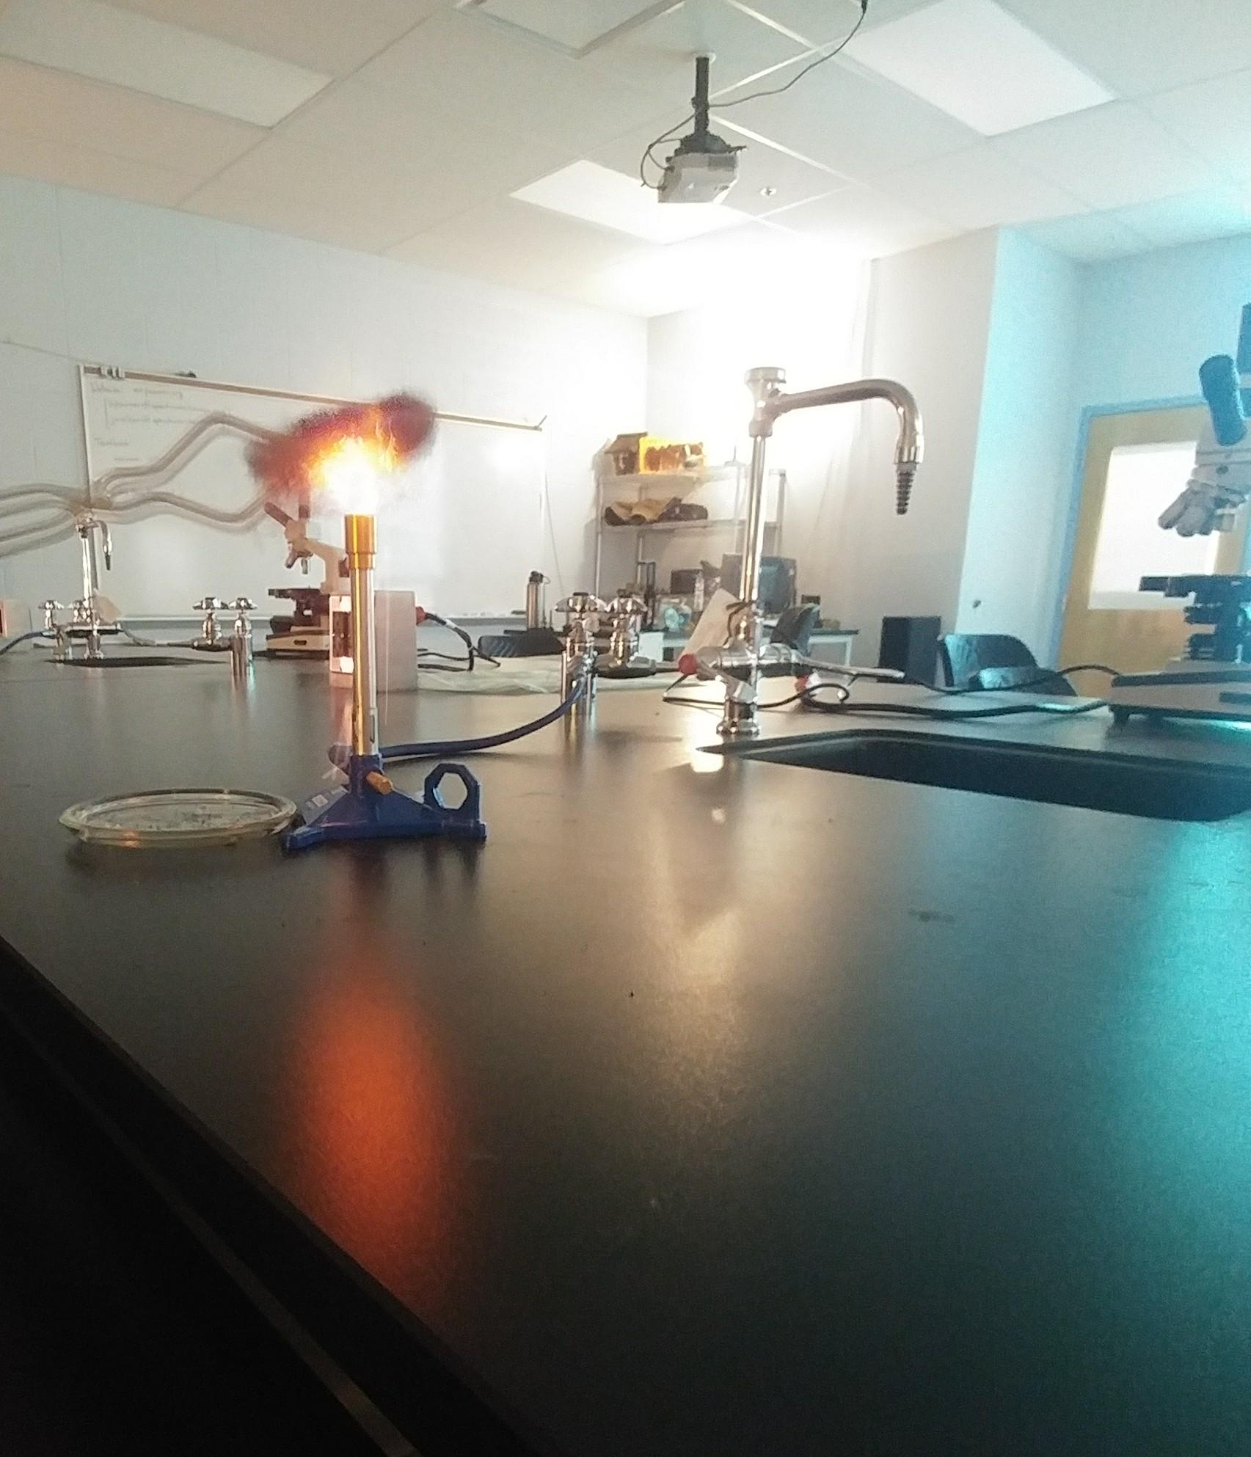

Answer any questions asked during the laboratory procedure.

Why is it glowing? The iron is reacting with the air to form iron oxide.

Is this how sparklers are made? Steel wool, like all metals, burns when enough energy is supplied. It's a simple oxidation reaction, like rust formation, except faster. This is the basis for the thermite reaction, but it's even easier to burn a metal when it has a lot of surface area. Here's a fun fire science project where you spin burning steel wool to create a fantastic sparkler effect.

**Conclusion :**

the steel wool would endure chemical changes and catch on fire. The wool catches on fire because the inside the battery the electrons of atoms are delocalized and thus are able to move around freely inside the metal. However, when both terminals of the battery, are connected by the steel wool, a complete circuit is made. One side of the circuit pulls the electrons in while the other terminal puts the elections back into the steel wool. Because of this, charges in the steel wool begin to flow fast, resulting in electrical friction. This friction causes the wire to glow orange and eventually

spark, causing the steel wool to catch fire.

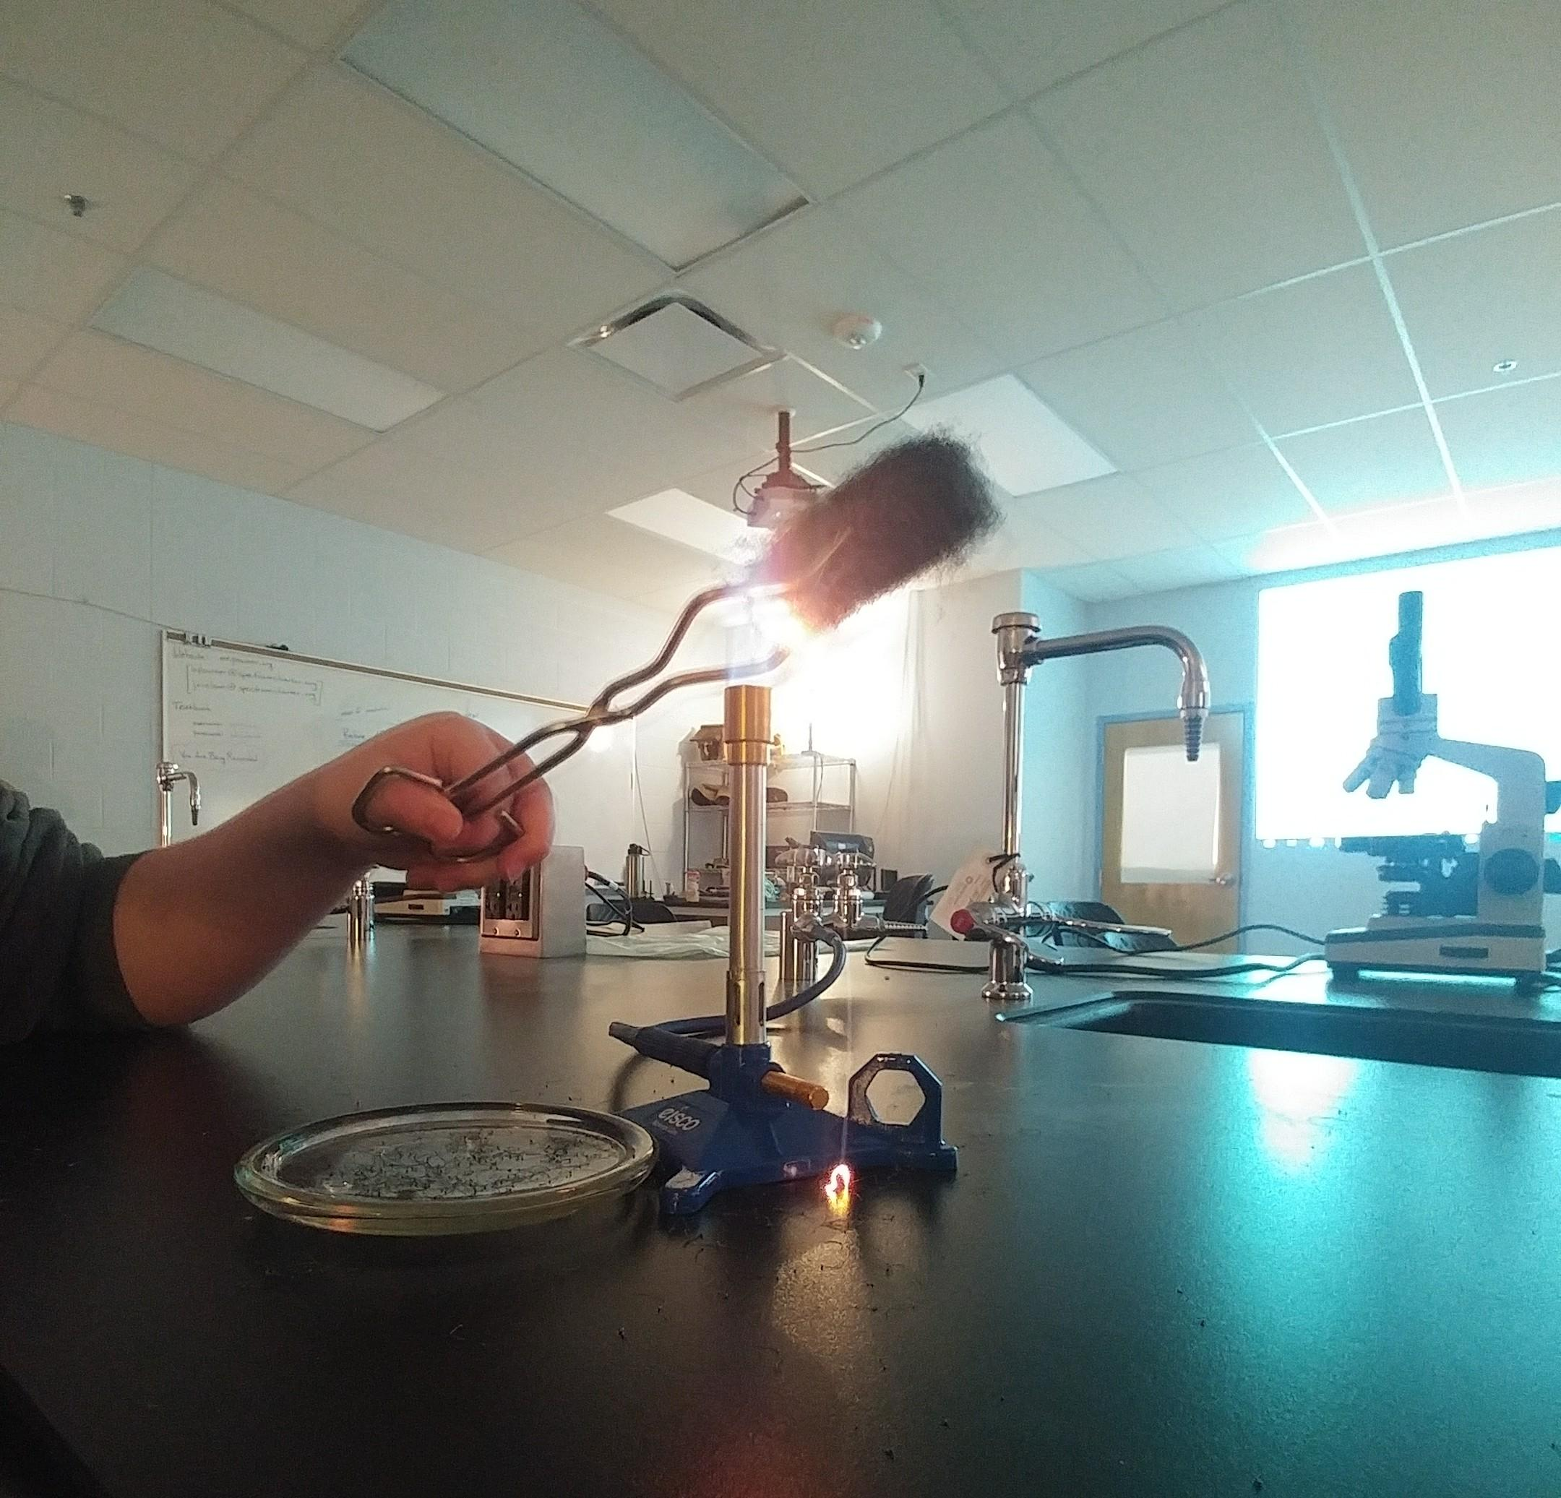

**Works Cited:**

[**https://www.instructables.com/id/Simple-Science-Burn-Steel-Wool/**](https://www.instructables.com/id/Simple-Science-Burn-Steel-Wool/)

https://www.metabunk.org/what-happens-when-you-burn-steel-wool.t10002/

**https://www.thoughtco.com/spinning-steel-wool-sparkler-607511**